DSC 430: Python Programming  
Assignment 0501: Dice and Cups

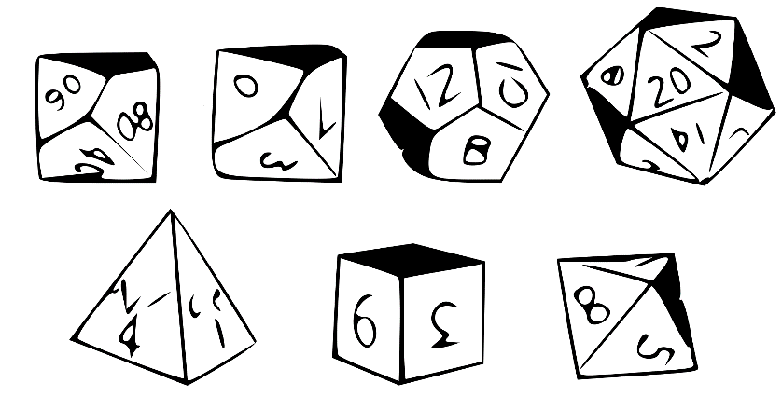

Write a class SixSidedDie. The class should include the following methods: roll(), getFaceValue(), and __repr__(). For example:

>>> d = SixSidedDie()

>>> d.roll()

3

>>> d.getFaceValue()

3

>>> d

SixSidedDie(3)

Create a TenSidedDie and a TwentySidedDie class. These two class must extend SixSidedDie. They must provide the same functionality. They must not re-implement any code that is not necessary.

Create a Cup class. A cup will hold several dice that may be rolled at once. The cup may hold any number of six-, ten-, or twenty- sided dice. For example, we could create a cup with one of each type of die as follows:

>>> cup = Cup(1,1,1)

…or we could create a cup with 3 six-sided dice…

>>> cup = Cup(3,0,0)

By default, the cup will contain one of each type of die.

>>> cup = Cup()

The Cup class should include the following functionality: roll(), getSum(), __repr__(). For example:

>>> cup = Cup(1,2,1)

>>> cup.roll()

28

>>> cup.getSum()

28

>>> cup

Cup(SixSidedDie(3),TenSidedDie(5),TenSidedDie(3),TwentySidedDie(17))

Record a three minute video in which you run the code. Then, present your code. Specifically, answer the following questions:

* Show how you **extend** sixSidedDie when writing TenSidedDie and TwentySidedDie.
* Show how you **compose** the cups class with the die classes.

Submission: Submit a single .py file containing all the code to the D2L. Do not zip or archive the file. Your code must include comments at the top including your name, date, video link, and the honor statement, “I have not given or received any unauthorized assistance on this assignment.” Each function must include a docstring and be commented appropriately.